**COMPUTER ARCHITECTURE COM (314 PRATICAL)**

|  |  |
| --- | --- |
| **NAME** | **MATRIC NO** |
| **AFOLABI TAIWO ABAYOMI** | **19/69/0053** |
| **OLADELE PHILIP** | **20/69/0002** |
| **EMMANUEL VICTORY** | **20/69/0013** |
| **AJAGWO BLESSINGS** | **20/69/0021** |
| **AYELESO TAIWO** |  |

**TOPICS:**

* Security In Processor Architecture
* Memory Compression Techniques
* Processor Virtualization

**TABLE OF CONTENT - SECURITY IN PROCESSOR ARCHITECTURE**

**CHAPTER 1: INTRODUCTION**

* 1. Overview of security processor architecture
  2. Importance of secure computer systems

**CHAPTER 2: FUNDAMENTALS OF SECURITY PROCESSORS**

2.1 Definition and key concepts

2.2 Evolution and historical background

**CHAPTER 3: SECURE EXECUTION ENVIRONMENTS**

3.1 Principles and design considerations

3.2 Isolation techniques and trusted execution environments

**CHAPTER 4: CRYPTOGRAPHIC ACCELERATORS**

4.1 Role of hardware acceleration in cryptography

4.2 Types of cryptographic algorithms and their implementation

**CHAPTER 5: SECURE BOOT MECHANISMS**

5.1 Boot process and its vulnerabilities

5.2 Secure boot principles and techniques

**CHAPTER 6: TRUSTED EXECUTION ENVIRONMENTS**

6.1 Introduction to secure enclaves

6.2 Use cases and practical applications

**CHAPTER 7: SECURITY MANAGEMENT UNITS**

7.1 Functions and responsibilities

7.2 Access control mechanisms and secure key storage

**CHAPTER 1 INTRODUCTION**

1.1 **Processor virtualization**, often referred to simply as virtualization, is a foundational technology that revolutionizes the way computing resources are utilized, managed, and deployed. It enables the creation of virtual instances or environments that mimic physical hardware, allowing multiple operating systems (OS) or applications to run simultaneously on a single physical processor. This technology has become increasingly vital in modern computing infrastructures1 due to its versatility, efficiency, and cost-effectiveness.

At its core, processor virtualization abstracts the underlying hardware resources, such as the CPU (Central Processing Unit), memory, and I/O devices, from the software running on top of it. This abstraction is achieved through a layer called a hypervisor or virtual machine monitor (VMM). The hypervisor sits between the physical hardware and the virtual machines (VMs), managing and allocating the hardware resources to each VM as needed.

1.2 **Aim and Objective**

**Aim:**

The aim of processor virtualization is to optimize the utilization of computing resources, enhance flexibility, and improve the efficiency of IT infrastructures by abstracting and virtualizing hardware components such as the CPU, memory, and I/O devices.

**Ojectives:**

1. Resource Optimization:

* Maximize the utilization of physical hardware resources by running multiple virtual machines (VMs) on a single physical server.
* Efficiently allocate CPU cycles, memory, and I/O bandwidth among virtual machines to ensure optimal performance and resource utilization.

1. Flexibility and Scalability:

* Enable dynamic provisioning and scaling of virtual machines to adapt to changing workload demands.
* Facilitate the migration of virtual machines between physical hosts to balance resource usage, improve fault tolerance, and support workload mobility.

1. Isolation and Security:

* Provide strong isolation between virtual machines to prevent interference and ensure the security and integrity of each VM's environment.
* Implement security features such as access control, encryption, and network segmentation to protect virtualized environments from unauthorized access and cyber threats.

1. Cost Reduction and Efficiency:

* Reduce hardware and operational costs by consolidating multiple workloads onto fewer physical servers, leading to lower power consumption, cooling requirements, and data center footprint.
* Improve operational efficiency by automating provisioning, management, and monitoring tasks through virtualization management tools and APIs.

1. High Availability and Disaster Recovery:

* Enhance system resilience and availability by implementing features such as live migration, fault tolerance, and automated failover to minimize downtime and ensure business continuity.
* Enable rapid backup, restoration, and recovery of virtual machine instances and data to mitigate the impact of hardware failures, software errors, or disasters.

1. Simplified Management and Administration:

* Provide centralized management interfaces and tools to streamline the deployment, configuration, monitoring, and troubleshooting of virtualized environments.
* Offer comprehensive reporting, analytics, and auditing capabilities to track resource usage, enforce compliance policies, and optimize performance.

**CHAPTER 2**

Processor virtualization has revolutionized the way computing resources are utilized and managed. By allowing a single physical processor to appear as multiple virtual processors, this technology enables the concurrent execution of multiple operating systems and applications on a single hardware platform. This comprehensive guide delves into the intricacies of processor virtualization, exploring its underlying principles, benefits, implementation strategies, and real-world applications.

**Principles of Processor Virtualization**

At the heart of processor virtualization lies the concept of abstraction, where the physical hardware is abstracted and partitioned into multiple virtual entities known as virtual machines (VMs). Each VM encapsulates an independent operating system instance along with its associated applications and resources. The hypervisor, also known as the Virtual Machine Monitor (VMM), acts as the intermediary layer between the physical hardware and the VMs, orchestrating their execution and managing resource allocation.

**Types of Virtualization**

Processor virtualization can be classified into several categories based on the degree of virtualization and the involvement of the guest operating system:

1. **Full Virtualization**: In full virtualization, the guest operating system runs unmodified, unaware of the underlying virtualization layer. The hypervisor intercepts and translates privileged instructions, allowing multiple VMs to run concurrently without requiring modifications to the guest OS.
2. **Para-Virtualization**: Para-virtualization involves modifying the guest operating system to make it aware of the virtualization layer. Specialized drivers facilitate direct communication between the guest OS and the hypervisor, improving performance and efficiency by reducing the overhead of instruction translation.
3. **Hardware-Assisted Virtualization**: Modern processors are equipped with hardware features designed to accelerate virtualization tasks. Technologies such as Intel's VT-x and AMD's AMD-V provide hardware-level support for virtualization, enhancing performance and security by offloading certain virtualization functions to the CPU.

**CHAPTER 3**

**Key Components of Processor Virtualization**

1. **Hypervisor (Virtual Machine Monitor):** The hypervisor is a critical component of processor virtualization, responsible for creating, managing, and monitoring VMs. It allocates physical resources such as CPU cycles, memory, and storage to individual VMs while ensuring isolation and security between them.
2. **Virtual Machines (VMs)**: VMs are the fundamental units of processor virtualization, each representing a self-contained instance of an operating system and its associated applications. VMs operate independently of each other, enabling multiple workloads to run concurrently on a single physical server.

**Benefits of Processor Virtualization**

Processor virtualization offers a myriad of benefits that encompass improved resource utilization, flexibility, scalability, and cost-effectiveness:

1. **Resource Utilization**: By consolidating multiple workloads onto a single physical server, virtualization optimizes resource utilization and reduces hardware sprawl, leading to cost savings and energy efficiency.
2. **Isolation and Security**: VM-level isolation enhances security by preventing the unauthorized access and interference between different operating systems and applications running on the same hardware platform.
3. **Flexibility and Scalability**: Virtualization provides agility and scalability, allowing organizations to dynamically allocate and reallocate computing resources based on changing workload demands without disruption.
4. **Disaster Recovery and High Availability**: Virtualization facilitates efficient disaster recovery and high availability solutions through features such as live migration and fault tolerance, ensuring business continuity and minimizing downtime.

**CHAPTER 4**

**Real-World Applications of Processor Virtualization**

Processor virtualization finds widespread adoption across various industries and use cases:

1. **Server Virtualization**: Server virtualization enables organizations to consolidate multiple server workloads onto a single physical server, optimizing resource utilization and simplifying management.
2. **Desktop Virtualization**: Desktop virtualization delivers centralized management and secure access to virtual desktops from any device, enhancing productivity and flexibility for end-users.
3. **Development and Testing**: Virtualized environments provide developers and QA teams with isolated testing environments, accelerating the software development lifecycle and improving code quality.
4. **Cloud Computing**: Virtualization forms the foundation of cloud computing platforms, allowing cloud providers to efficiently provision and manage virtualized resources on-demand, catering to diverse customer requirements.

**Advanced Concepts and Implementation Strategies in Processor Virtualization**

Beyond the foundational principles and benefits of processor virtualization, there exist several advanced concepts and implementation strategies that further enhance its capabilities and address specific use cases**:**

1. **Nested Virtualization**:

Nested virtualization refers to the ability to run virtual machines within virtual machines. This technique is particularly useful for testing and development environments, where nested VMs can simulate complex network topologies or multi-tier application architectures.

2. **Memory Over commitment**:

Memory over commitment allows the hypervisor to allocate more virtual memory to VMs than the physical memory available on the host system. Through techniques such as memory page sharing and transparent page sharing, the hypervisor optimizes memory utilization while ensuring performance and reliability.

3. **GPU Virtualization**:

Graphics Processing Unit (GPU) virtualization extends virtualization to include GPU resources, enabling multiple VMs to share GPU hardware efficiently. This capability is essential for accelerating graphics-intensive workloads, such as virtual desktop infrastructure (VDI) and machine learning applications.

4. **Storage Virtualization**:

Storage virtualization abstracts physical storage devices into virtualized storage pools, which can be dynamically allocated to VMs based on their requirements. Technologies such as Storage Area Networks (SANs), Network-Attached Storage (NAS), and Software-Defined Storage (SDS) facilitate centralized management and efficient utilization of storage resources.

5. **Network Virtualization**:

Network virtualization decouples network resources from underlying hardware, allowing for the creation of virtual networks with customized topologies and policies. Virtual switches, routers, and firewalls enable network isolation, segmentation, and traffic shaping within virtualized environments.

6. **Hyper convergence**:

Hyper convergence integrates compute, storage, and networking resources into a single, cohesive infrastructure stack. By converging these components, hyperconverged systems simplify deployment, management, and scalability, making them ideal for virtualized environments, edge computing, and cloud-native architectures.

7. **Orchestration and Automation**:

Orchestration and automation tools streamline the deployment, provisioning, and management of virtualized infrastructure. Platforms such as VMware vSphere with vRealize Automation, Microsoft System Center, and open-source solutions like OpenStack and Kubernetes enable administrators to define policies, workflows, and service catalogs for efficient resource utilization and self-service provisioning.

8. **Hybrid and Multi-Cloud Virtualization**:

Hybrid and multi-cloud virtualization extend virtualization principles across diverse cloud environments, including public, private, and hybrid clouds. Through cloud management platforms and services, organizations can seamlessly migrate workloads, implement disaster recovery solutions, and optimize costs across multiple cloud providers while maintaining interoperability and portability.

9. **Dynamic Resource Allocation**:

Dynamic resource allocation enables the hypervisor to adjust CPU, memory, and storage resources allocated to VMs based on real-time demand. Through features like Dynamic Memory Balancing (DMB) and Distributed Resource Scheduler (DRS), virtualized environments can optimize resource utilization, improve performance, and ensure SLA compliance.

10. **Fault Tolerance and High Availability**:

Fault tolerance and high availability mechanisms within virtualization platforms ensure continuous operation and data integrity by replicating critical VMs across multiple physical hosts. Technologies such as VMware Fault Tolerance (FT) and Microsoft Hyper-V Replica provide seamless failover capabilities, minimizing downtime and data loss in the event of hardware failures or disasters.

11. **Live Migration and VM Mobility**:

Live migration allows administrators to move running VMs between physical hosts without service interruption. Whether for load balancing, hardware maintenance, or disaster avoidance, live migration enables efficient resource utilization and minimizes downtime while ensuring continuous availability of applications and services.

12. **Backup and Disaster Recovery**:

Virtualization simplifies backup and disaster recovery operations by leveraging snapshotting, replication, and backup integration features provided by hypervisor vendors and third-party solutions. VM-level backups, combined with granular recovery options, streamline data protection and ensure business continuity in the face of unforeseen events.

13. **Compliance and Security**:

Virtualization platforms offer a range of security features to protect VMs and mitigate risks associated with data breaches and compliance violations. Role-based access control (RBAC), encryption, and secure boot mechanisms enhance VM security, while compliance frameworks such as PCI DSS and HIPAA provide guidelines for ensuring regulatory compliance within virtualized environments.

14**. Cost Optimization and ROI**:

Virtualization delivers tangible cost savings through reduced hardware acquisition and maintenance costs, lower power and cooling expenses, and streamlined management overhead. By consolidating workloads onto fewer physical servers, organizations can optimize infrastructure spending and achieve a rapid return on investment (ROI) while scaling their virtualized environments to meet evolving business demands.

**CHAPTER 5**

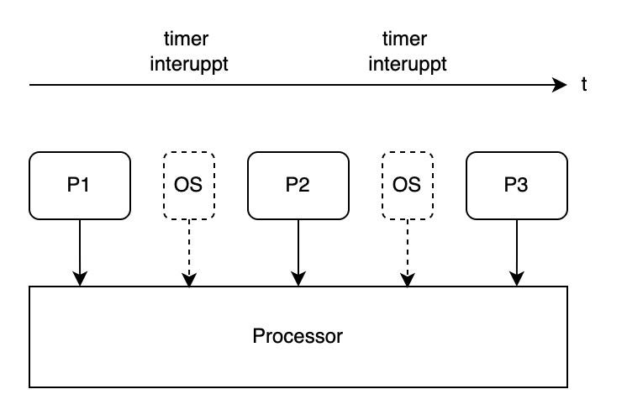**Processor Virtualization Chat**

With this we can see how Limited Direct Execution got its name, it allows Direct Execution of the processes on the hardware, however that execution is Limited and can be interrupted by the Hardware.

This solves both of the problems we discussed earlier and is a solid approach for CPU virtualization which is used even today, however, there is one tiny detail that remains to be discussed.

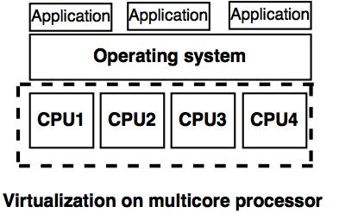The diagram below shows a virtualization on multicore processor.